Analysis Using Decision Tree Classifier Model:

DOC 1: AUC_Test and Auc_Train
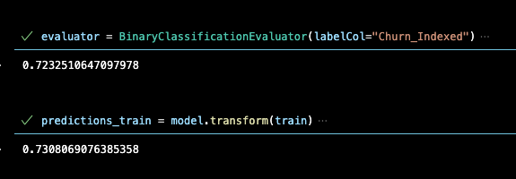
Doc:2 AUC results by attributes:
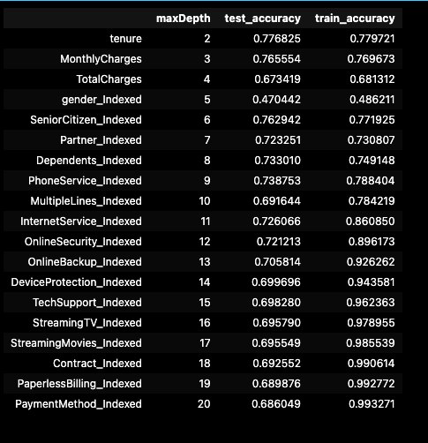

DOC3: Decision Tree FEATURE IMPORTANCE
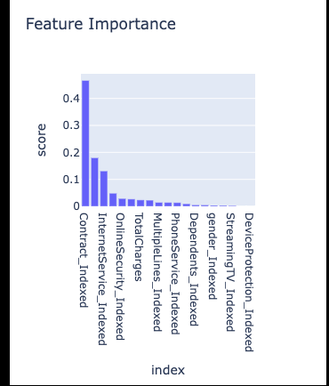

Doc4: Auc_Roc and Auc_pr
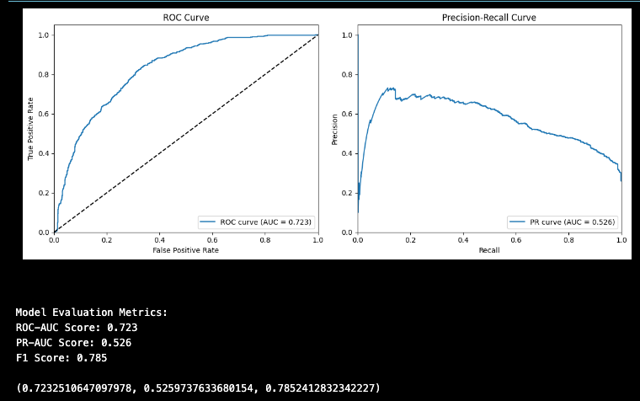

Analysis using H2o.Ai Stacked Ensemble

Leaderboard:

Feature importance:
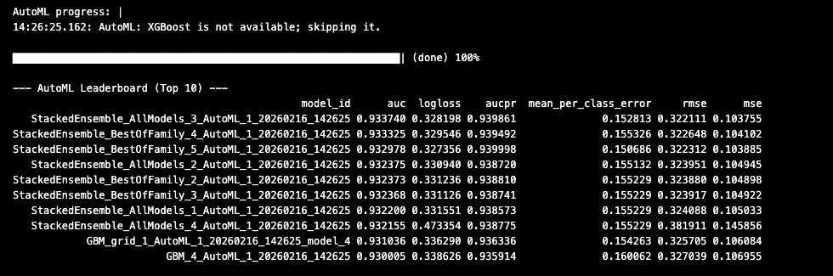
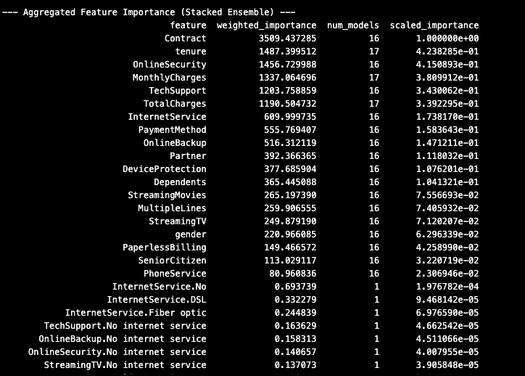
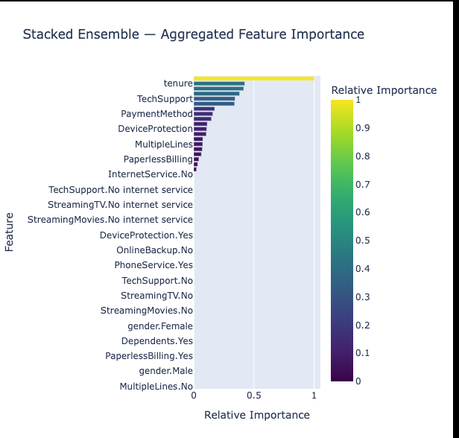

Doc6: Model Details

Doc 7: Model Summary of Evaluation and confusion matrix
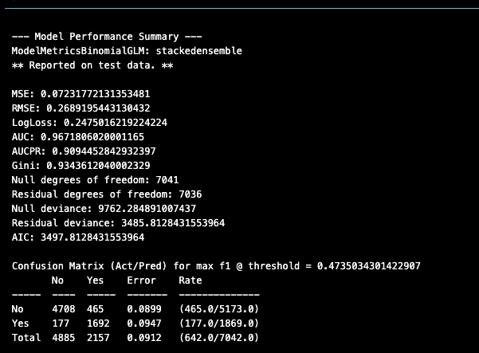

ROC
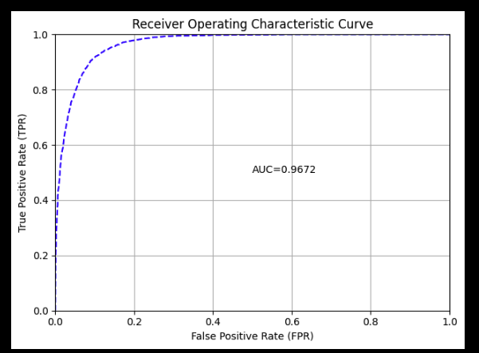

AUC-PR
